Hands on 1
Create a Spring Web Project using Maven
src/main/java - Folder with application code
package com.cognizant.springlearn;

import org.slf4j.Logger;
import org.slf4j.LoggerFactory;
import org.springframework.boot.SpringApplication;
import org.springframework.boot.autoconfigure.SpringBootApplication;

@SpringBootApplication
public class SpringLearnApplication {

private static final Logger LOGGER = LoggerFactory.getLogger(SpringLearnApplication.class);

public static void main(String[] args) {
LOGGER.info("Starting SpringLearnApplication main method...");
SpringApplication.run(SpringLearnApplication.class, args);
LOGGER.info("SpringLearnApplication started successfully!");
}
}

- src/main/resources - Folder for application configuration
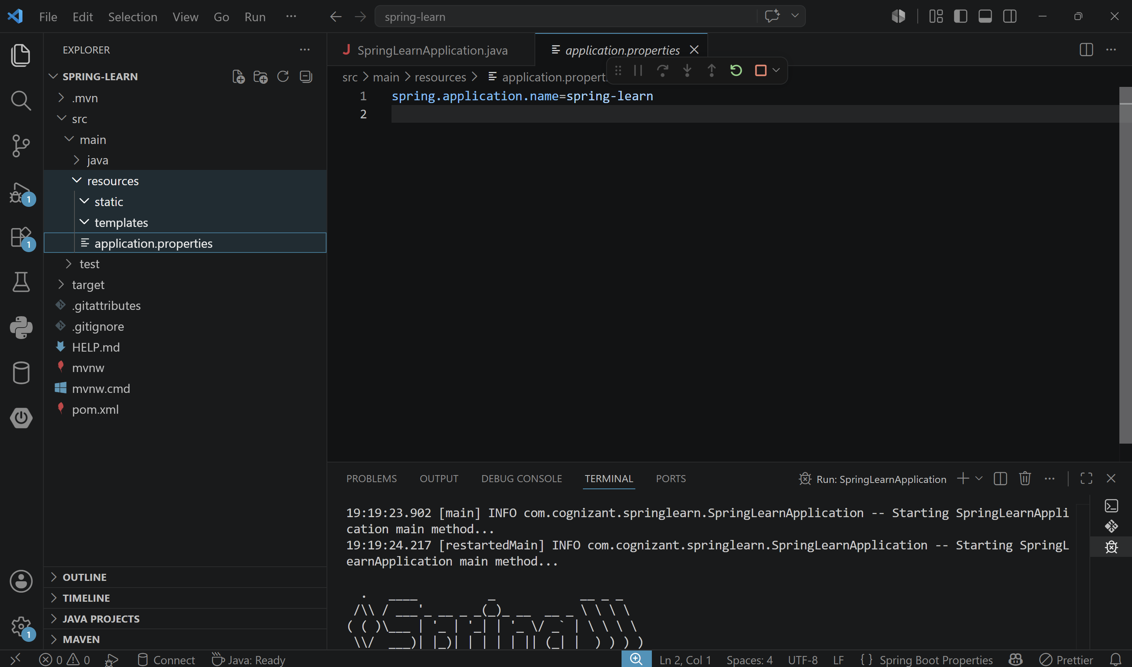
- src/test/java - Folder with code for testing the application
package com.cognizant.springlearn;

import org.junit.jupiter.api.Test;
import org.springframework.boot.test.context.SpringBootTest;

@SpringBootTest
class SpringLearnApplicationTests {

@Test
void contextLoads() {
}

}

OUTPUT :
